**Milestone: Interviews and user Personas**

Justin Starr

Department of STEM

CS 319 – UI/UX Design and Development

Professor Erin Tirrell

July 9, 2023

# Milestone: Interviews and User Personas

Based on an app that a client has asked to have developed, potential customers were identified to be interviewed for the purpose of collecting relevant user information. Each interview lasted approximately 30 minutes and covered various topics that were identified during the planning stage. Comprehensive notes were taken, and the following is an analysis of the conducted interviews and their findings.

A primary issue that was identified that had not been considered before was that the users would want the app to be more interactive or engaging than how they were described that the app would function. While they all shared the similar thought that the initial idea of the app is beneficial to them, they wanted to be able to do something more with the information they were being provided about the ingredients of the products they scanned. Another issue that was identified is that there are potential customers who may not fully understand the functionality/capabilities of their mobile devices, therefore, had an expectation that the app should also provide certain “settings” that the device is capable of handling for the specific needs of the user. An example is the ability to change the font size to make the information presented in the app larger or smaller depending on the user.

During the interviews, a particular pattern/theme that arose was that the users wanted to have the ability to do something with the information that was produced as a result of scanning products. Most common was that potential customers wanted to be able to have a grocery list incorporated into the app that could be referenced during a shopping trip and then have the ability to scan the product from the grocery list and view how healthy or unhealthy the ingredients in those products are. They also wanted to have some sort of ability for the app to remember decisions they make about the products they scanned, whether it be some sort of way to rate or mark products as products they would or would not purchase in the future. Additionally, it was important to have the ability to compare unhealthy products with alternative healthy products. In one case, it was important for products to be sourced locally, and that these products are preferable. The most common theme was that, depending on the information provided about a product’s ingredients, certainly impacted their choice as to whether they would buy a product. Even when asked if they would still purchase a product they normally buy after finding out it was unhealthy, everyone said that the information provided would sway their purchasing decisions. Another theme/pattern that arose was that there seemed to be no amount of information that the app could provide that would be too much information. However, it was also important that the information that they are presented with also be easily understood.

Keywords often used in the interviews were healthy, unhealthy, diet/dietary, information, and ingredient(s), all of which helped identify user priorities. These priorities included but were not limited to having information about products they consume and the specific ingredients within those products. All the interviewed users had a high priority for their health. Having an app that could incorporate solutions into their life that would help them make better choices about the food they consume was a priority for all of them. Another priority was some way for the users to remember information about previously scanned products and the choices they have already made so that they did not have to continuously scan the same products every time they went grocery shopping. While they all agreed that the app would be extremely informative to them, it was easy to acknowledge a priority for them to be able to incorporate the app into their life in a way that would make purchasing decisions easier or faster for them the more they used the app.

To better understand who the users are likely to be, the following is a description of potential customers and their major needs and goals. One of the greatest aspects of this app is that any person who eats food and cares about the food they put into their body can benefit from using this application. The target age group would be around 14 or 15 years of age and up, being that this is likely around the age that people start learning more about their health, the food they consume, and how healthy or unhealthy it can be. While it is hard to determine the exact level of education needed, people who can read and understand nutritional information have enough education to use this app. No level of income is required to be able to use this app. No matter how much money a person makes, they can still make decisions about the food they consume, even though the quality of products a person can purchase is often dependent on income. People from all walks of life can benefit from using this app, no matter their profession. The primary purpose for engaging is so that users can easily find out how healthy or unhealthy the products they might consume are; ultimately leading to healthier, happier, and hopefully, longer life. The information needed to enable this is to better understand the ingredients within products, what they are, and the effects they can have on their bodies. Users are most likely to engage while shopping, where they can see the various products throughout different food categories, wherever they shop for their food needs. It is also likely that people will engage at home also, especially if additional features, such as a shopping list, can be incorporated into the app. Users will use the device from mobile devices where they can use it anywhere they have an internet connection and are expected to have a wide range of use times depending on the type of user and their primary purpose for using the app. It is possible that the more a user learns about the products they might use it less, but it is also expected that people like to try new food products and will continue to use this product regularly to help them make healthier food choices.

**Interview 1 Notes**

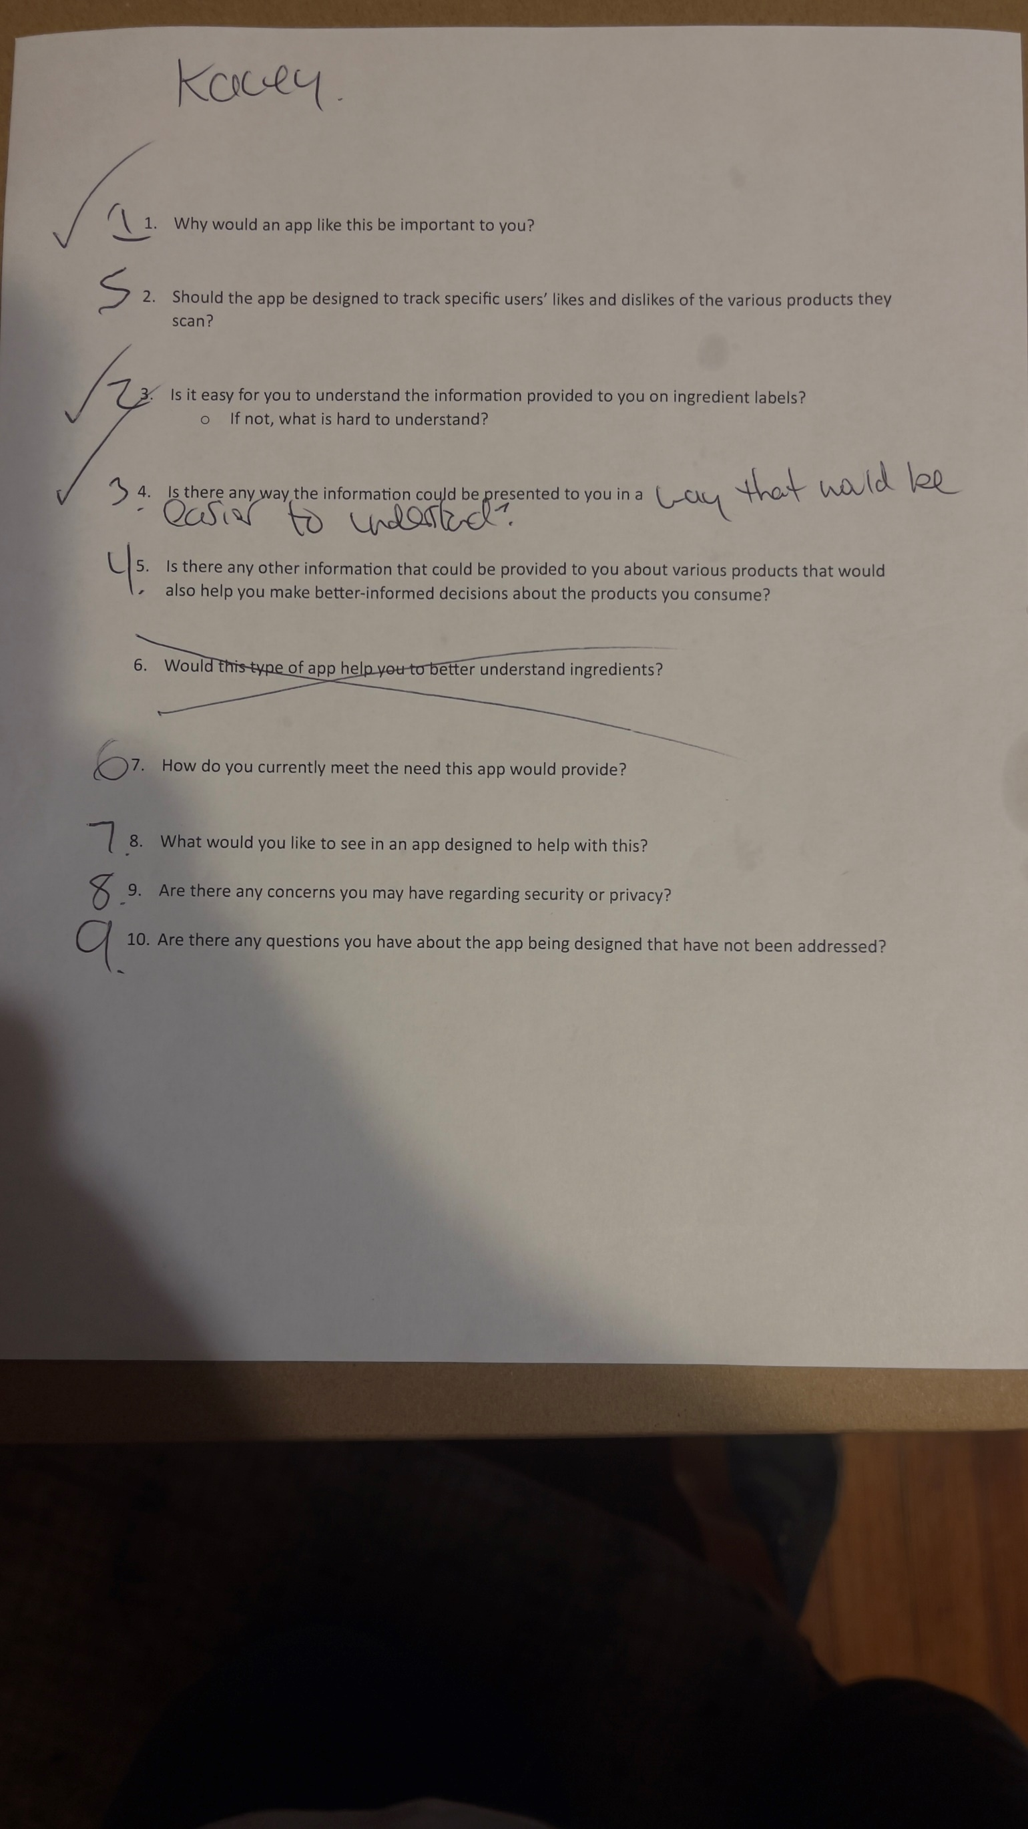

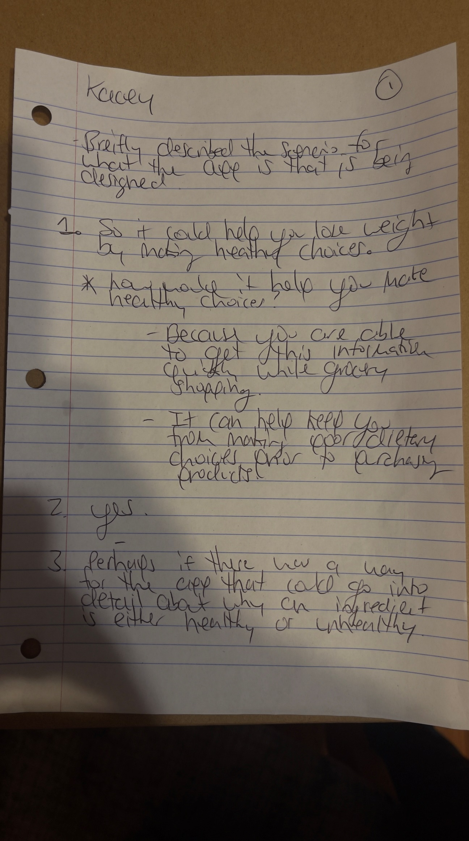



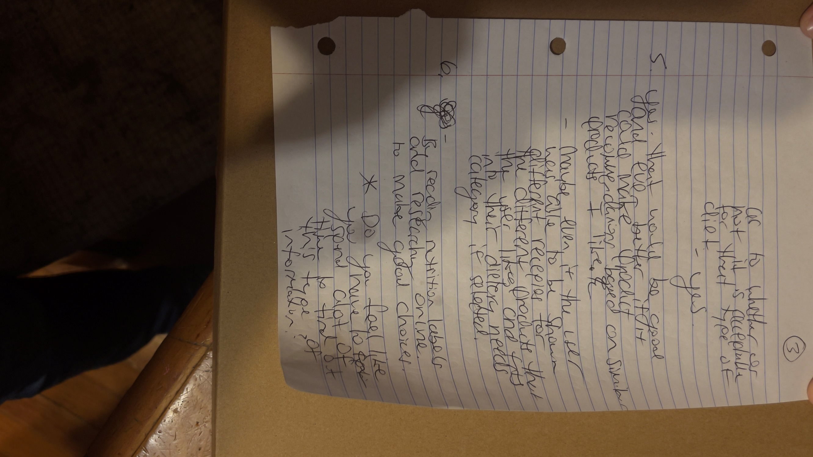

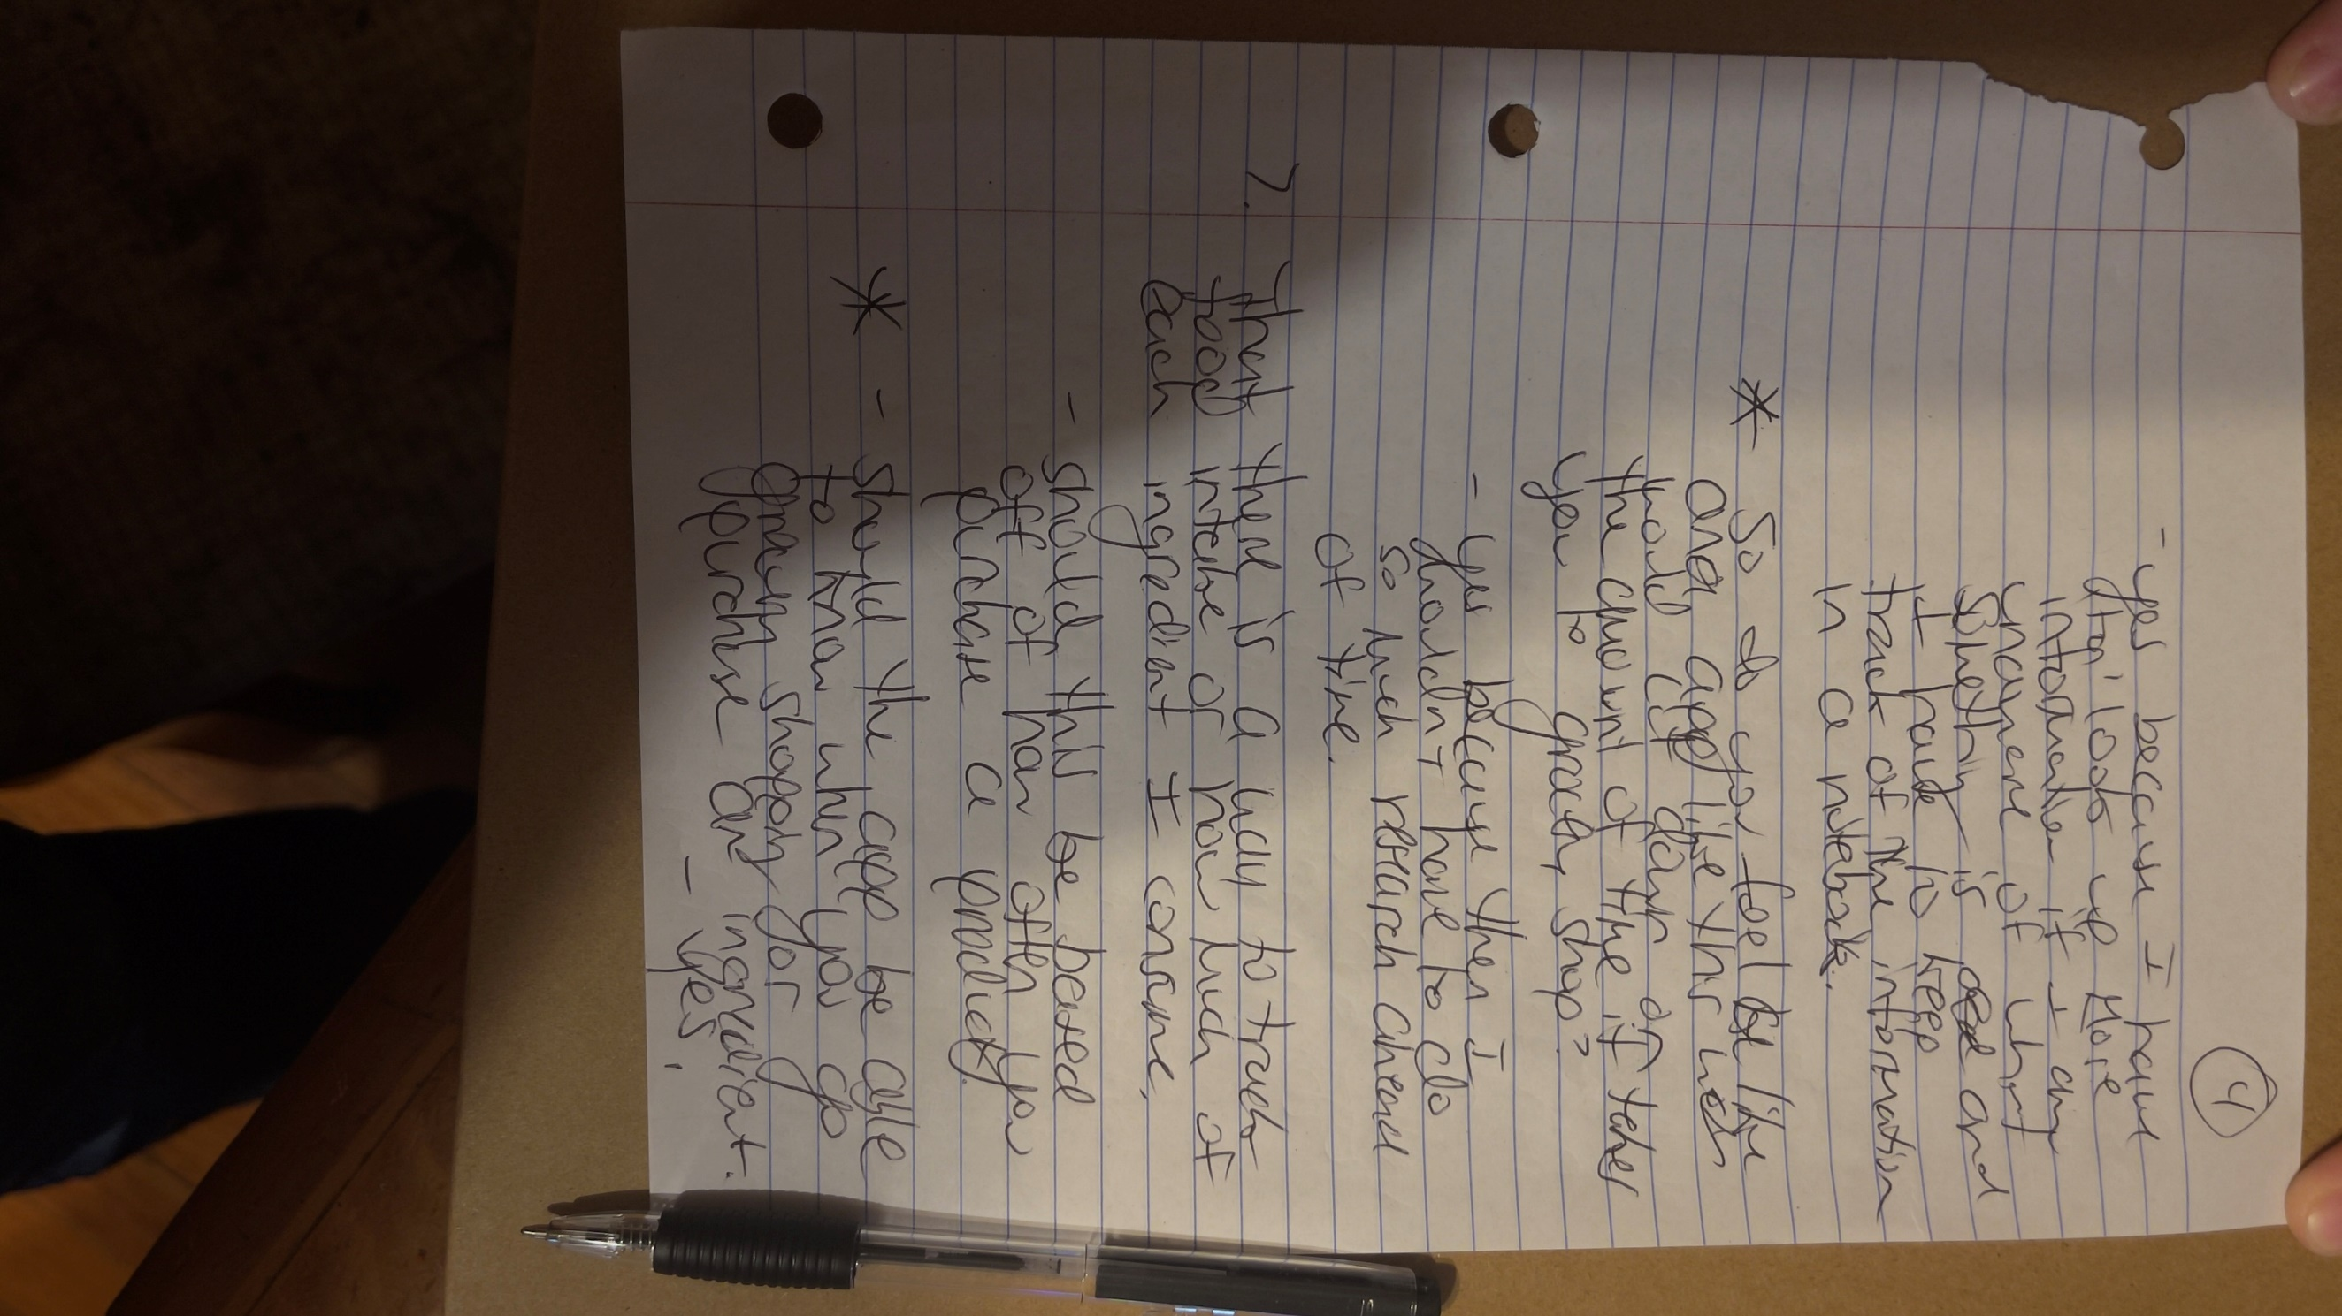





**Interview 2 Notes**

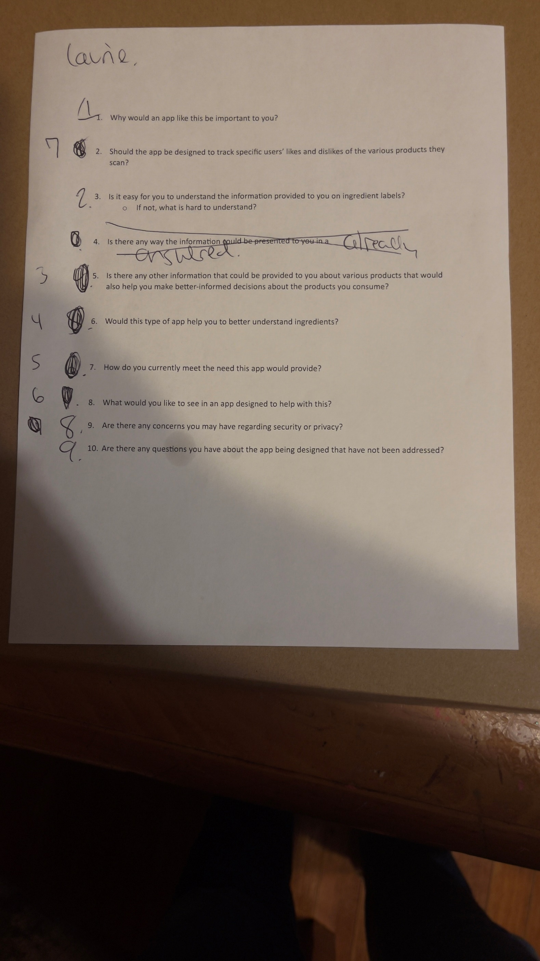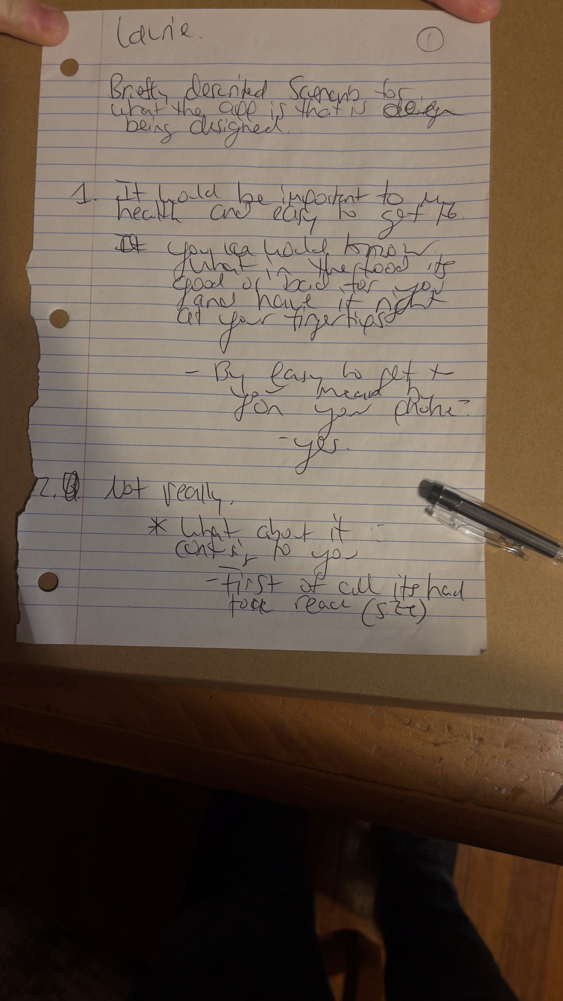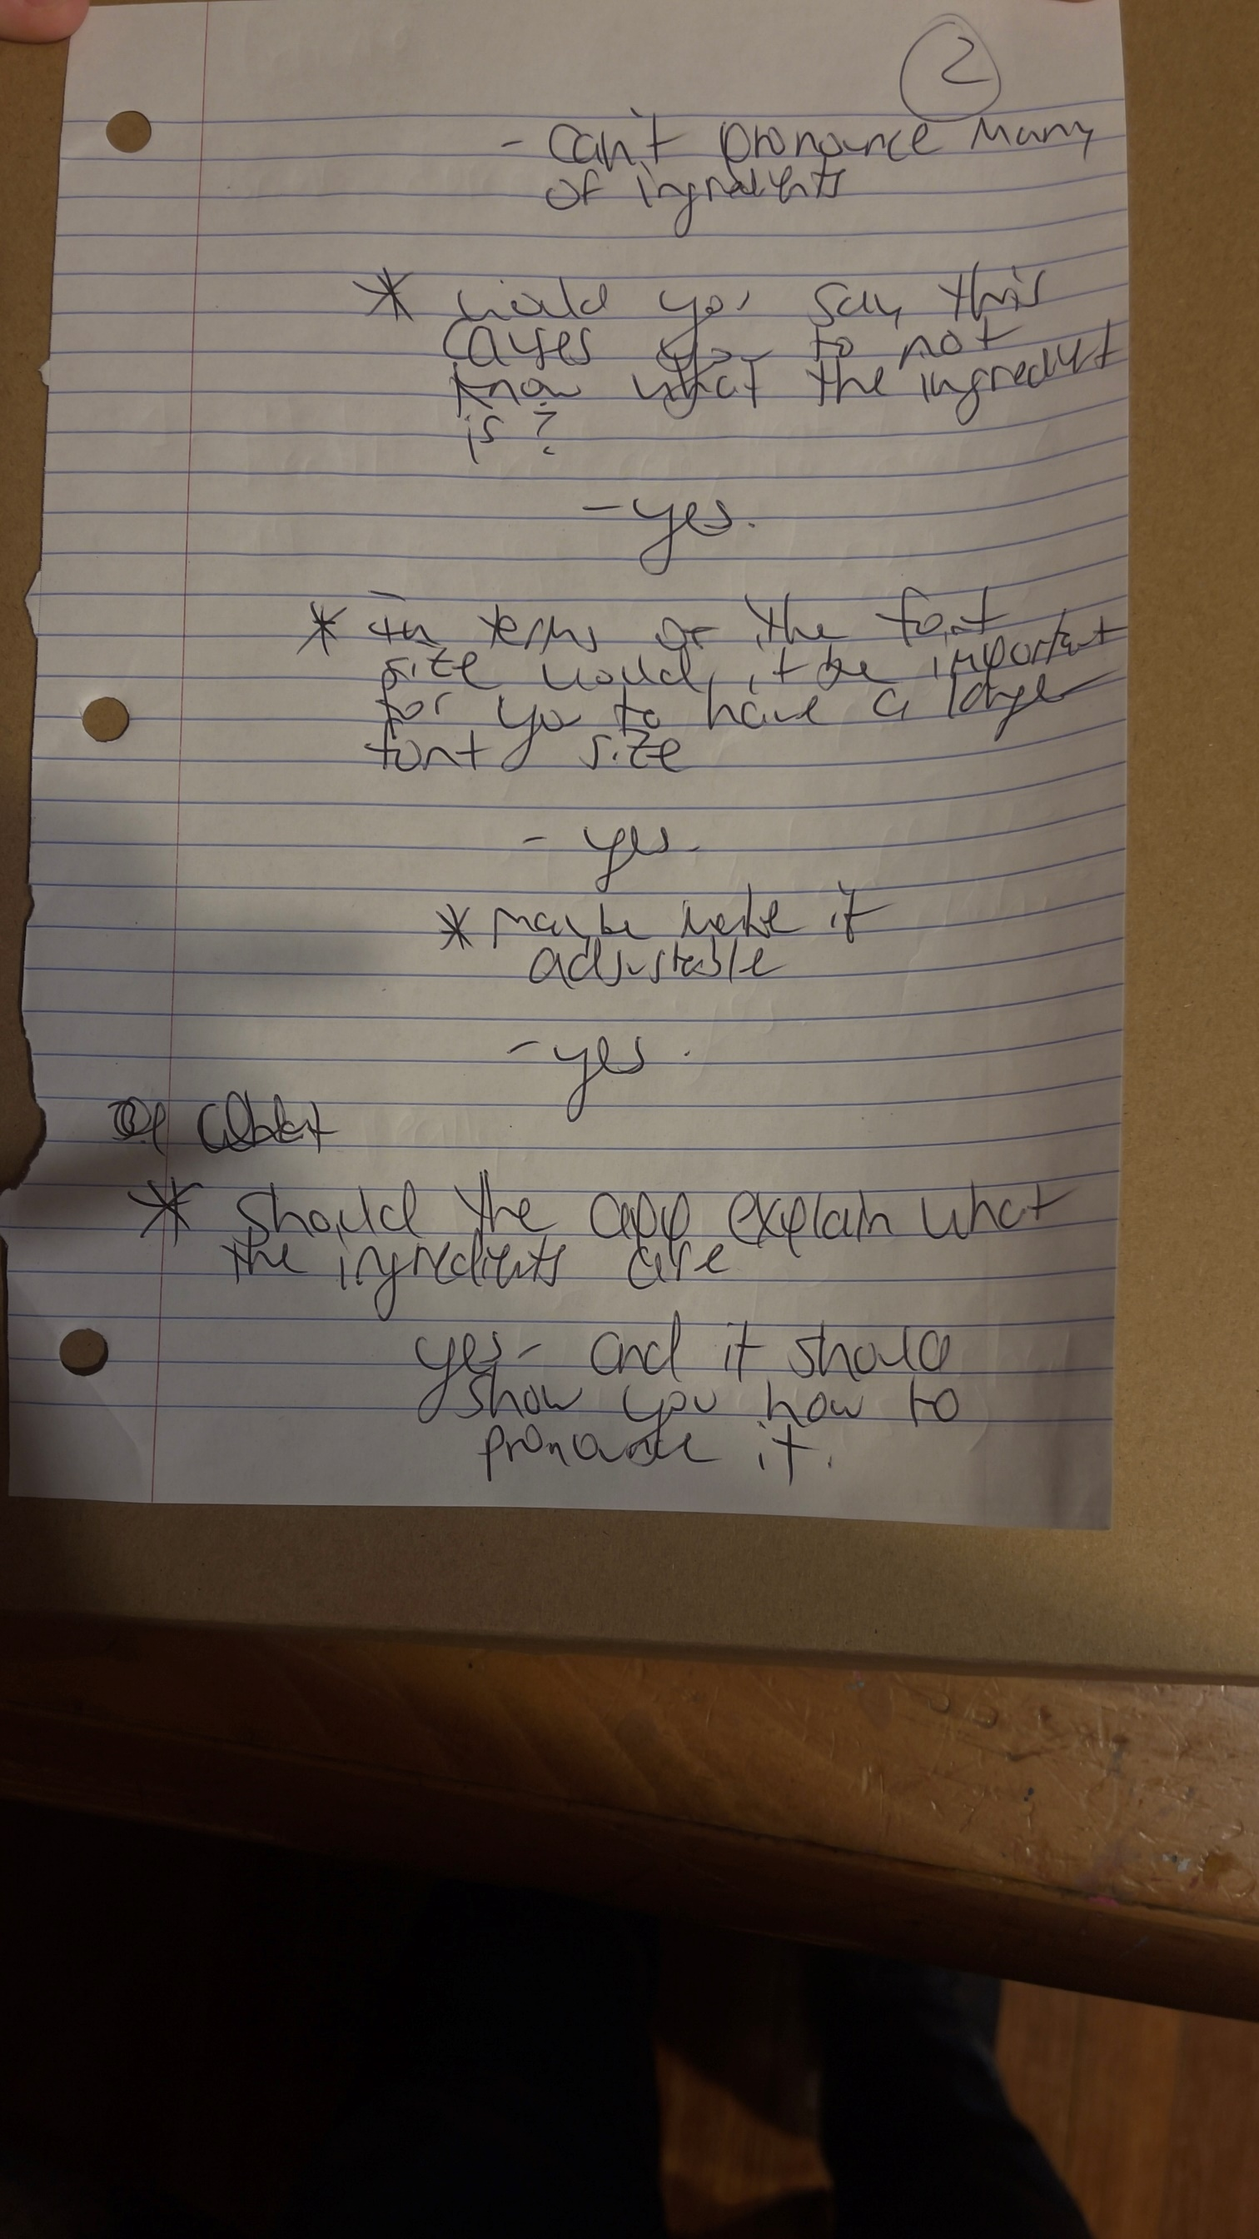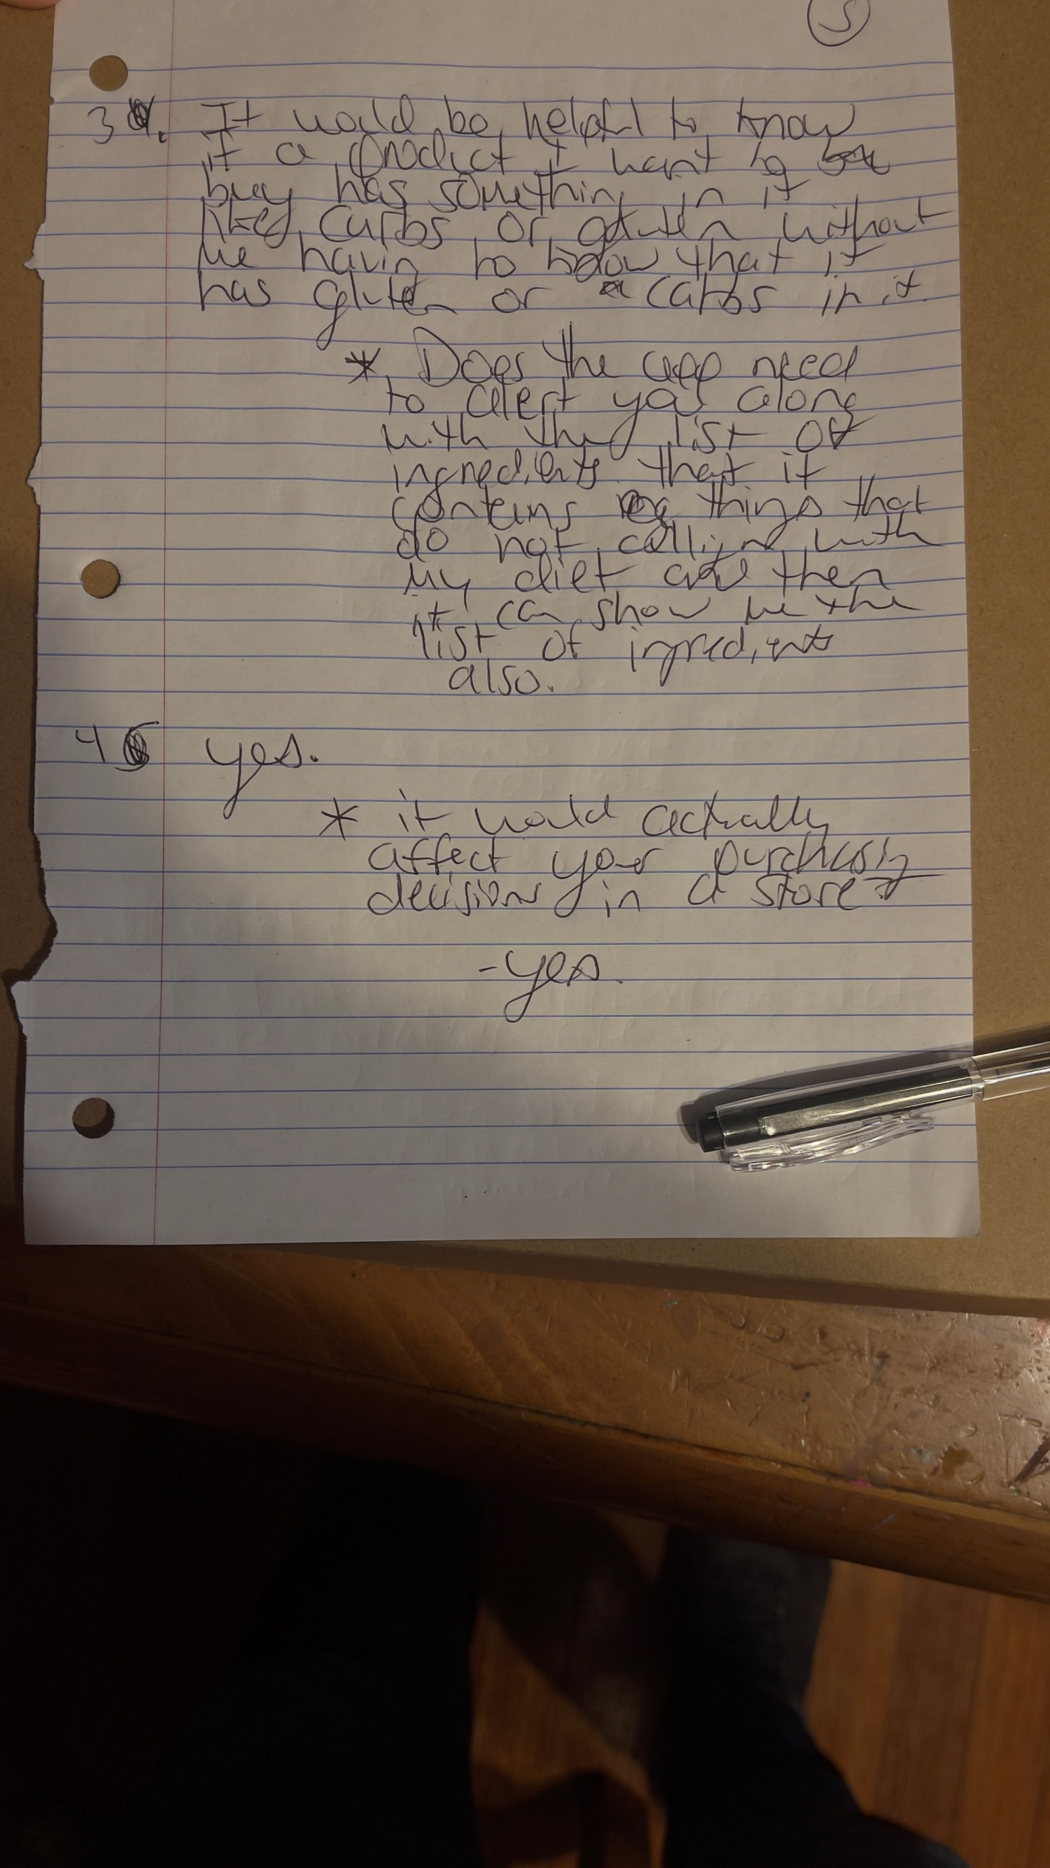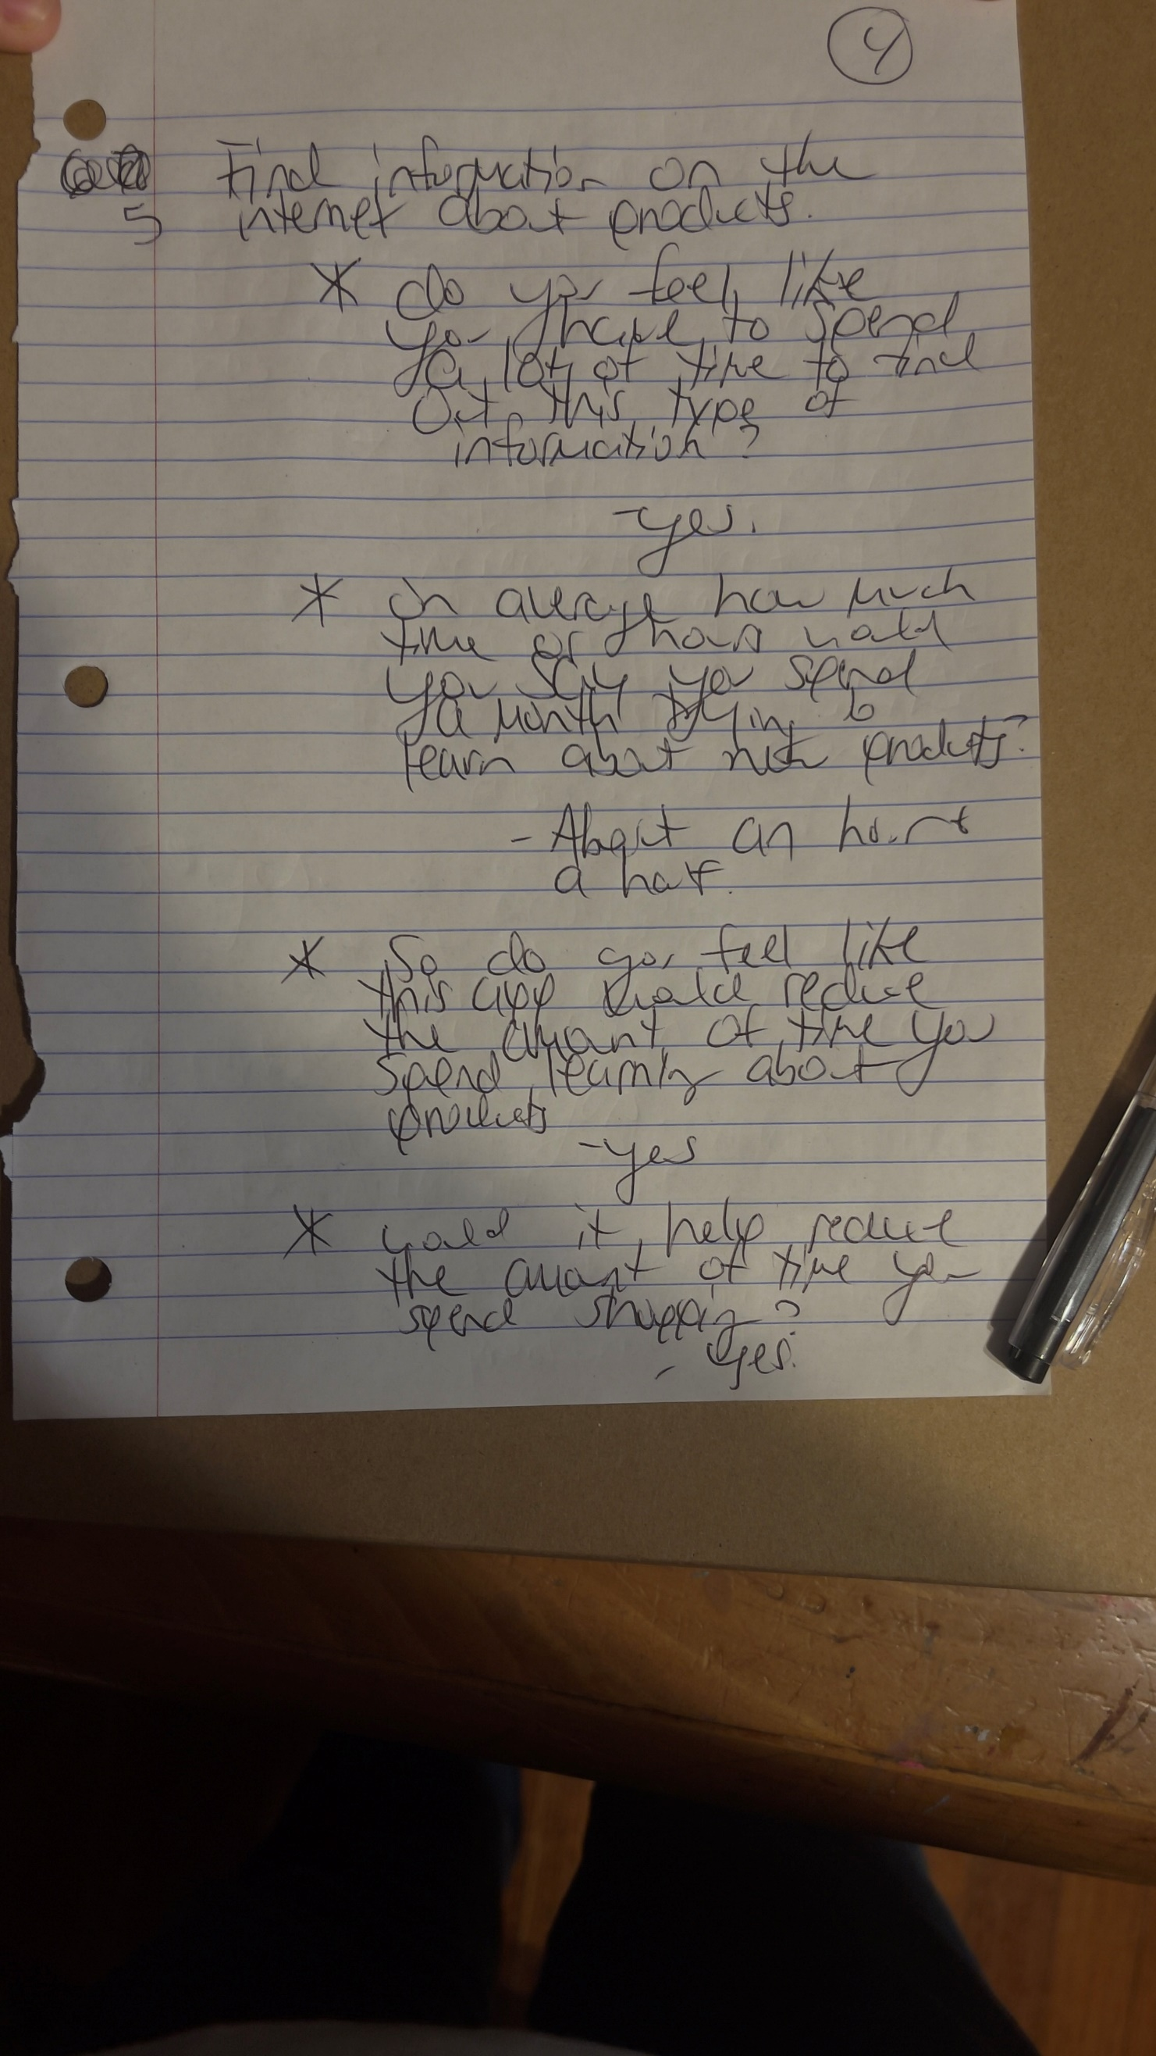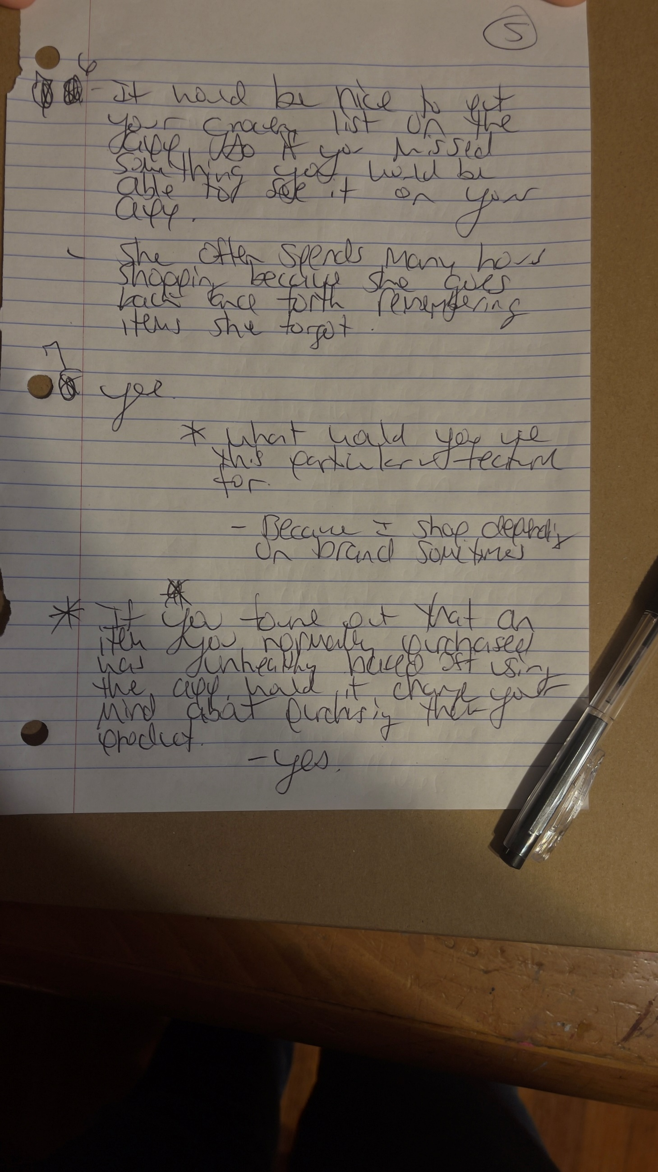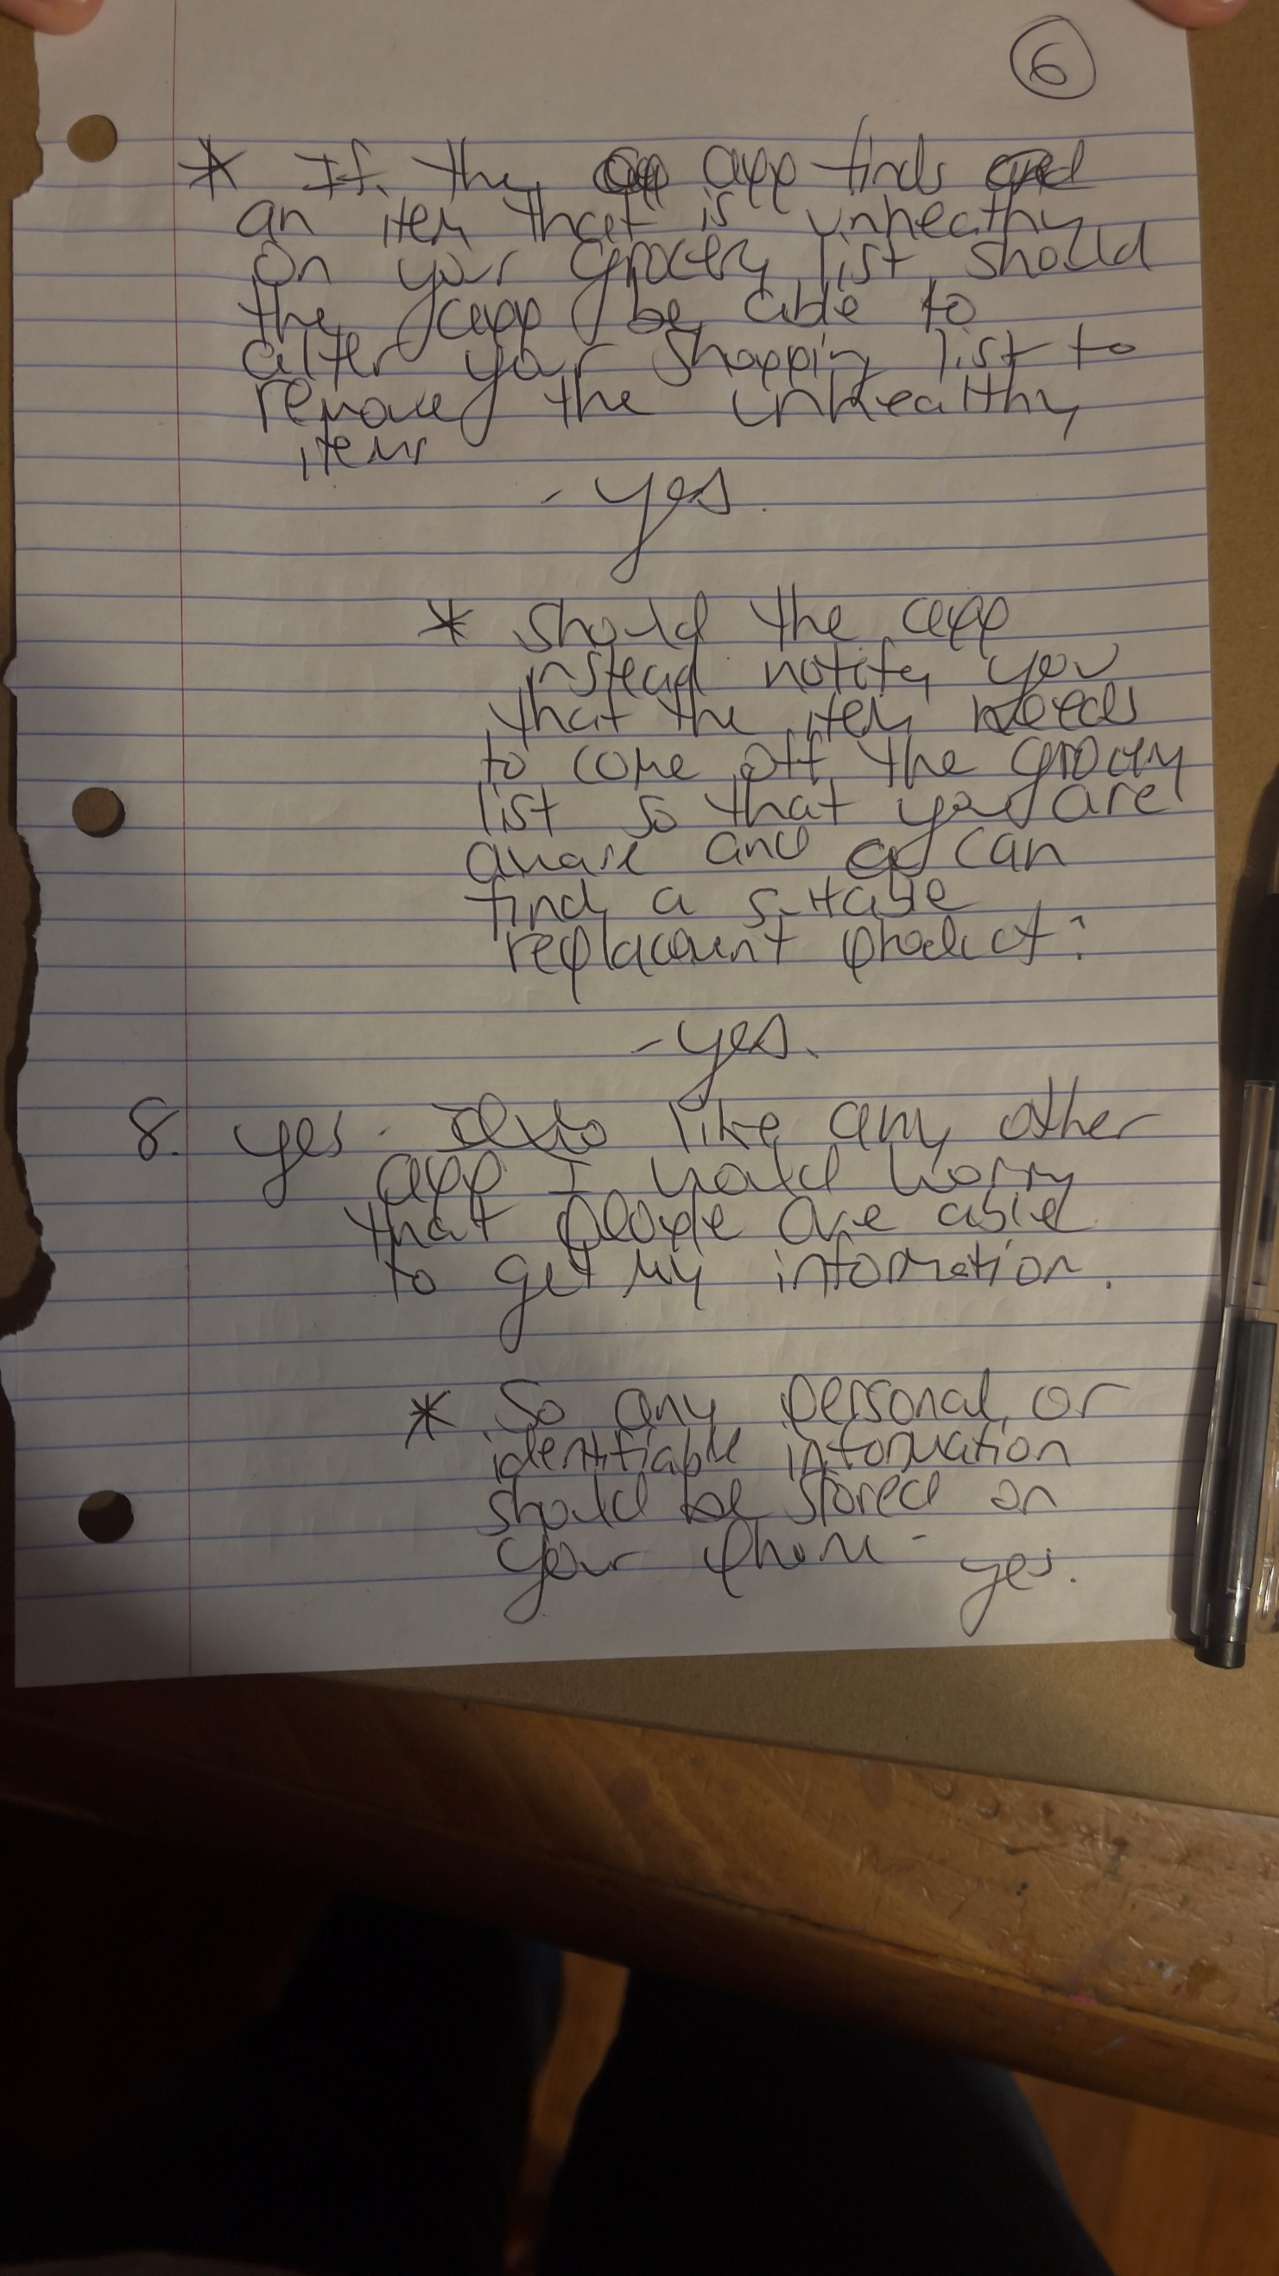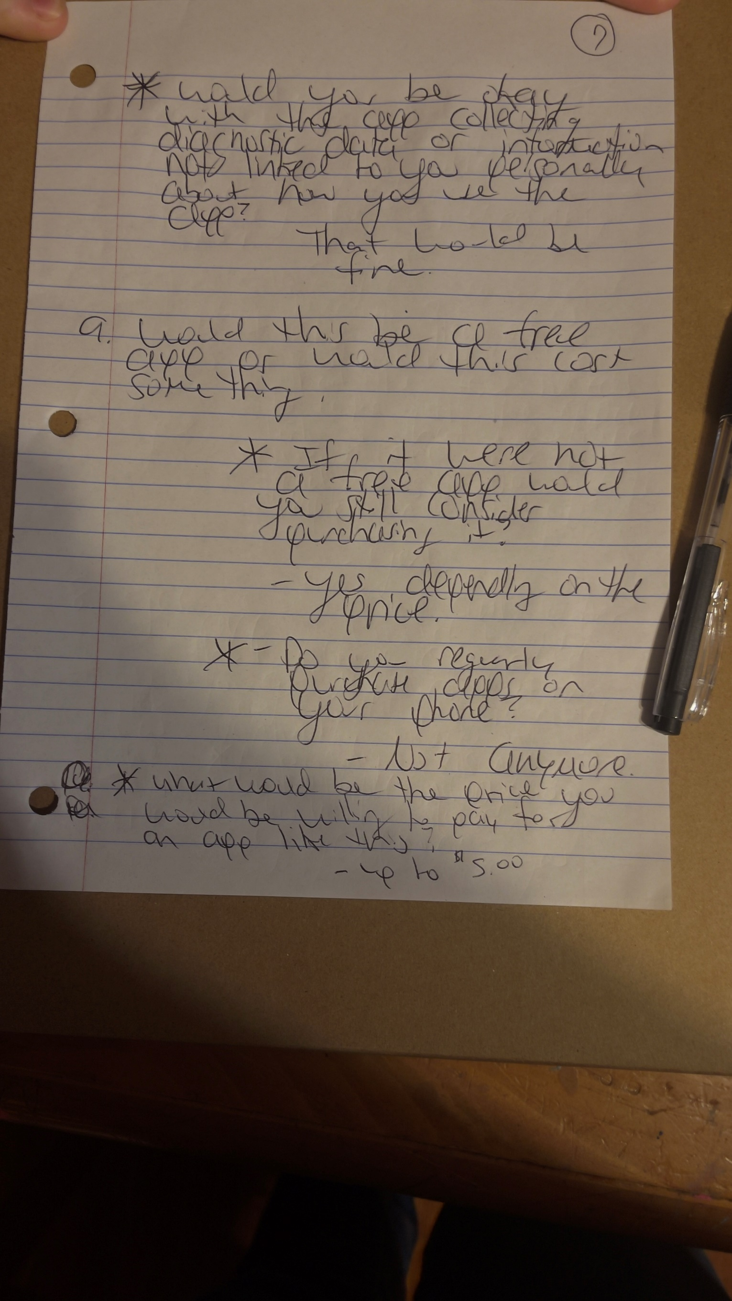

**Interview 3 Notes**

